Q1.

f(x)=sin(x)− $\frac{1}{1000}$ sin(1000x)

(a)

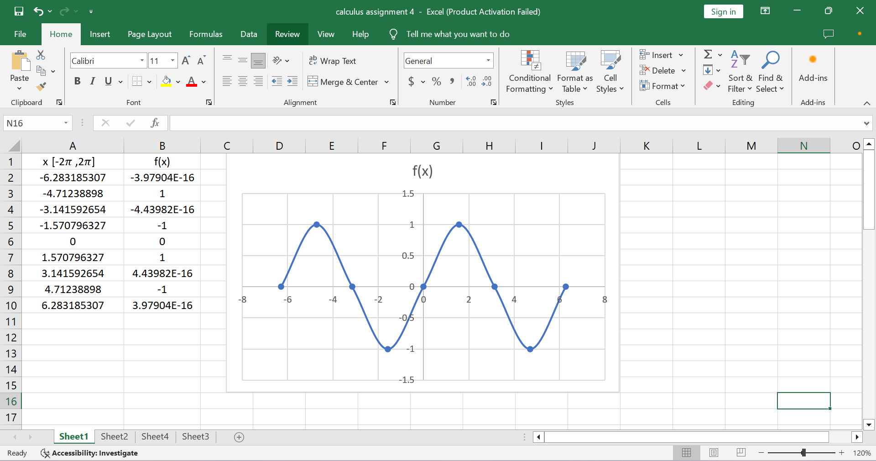

The slope of the graph at the origin appears to be 1.

(b)

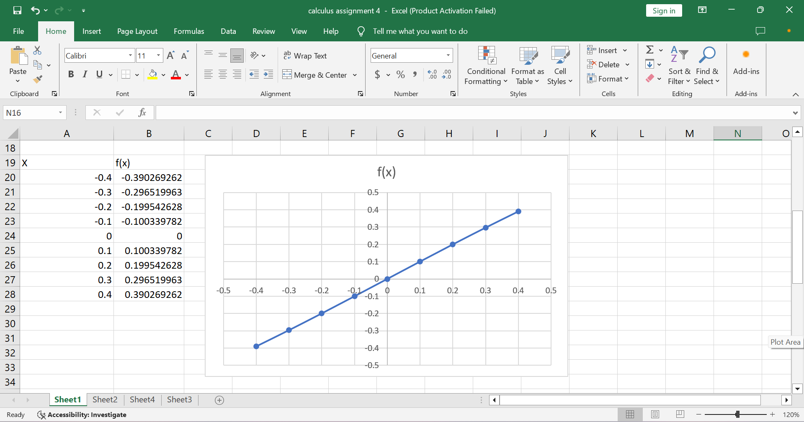

The slope of the graph at the origin appears to be 1: f ′ (0) = 1.

(c)

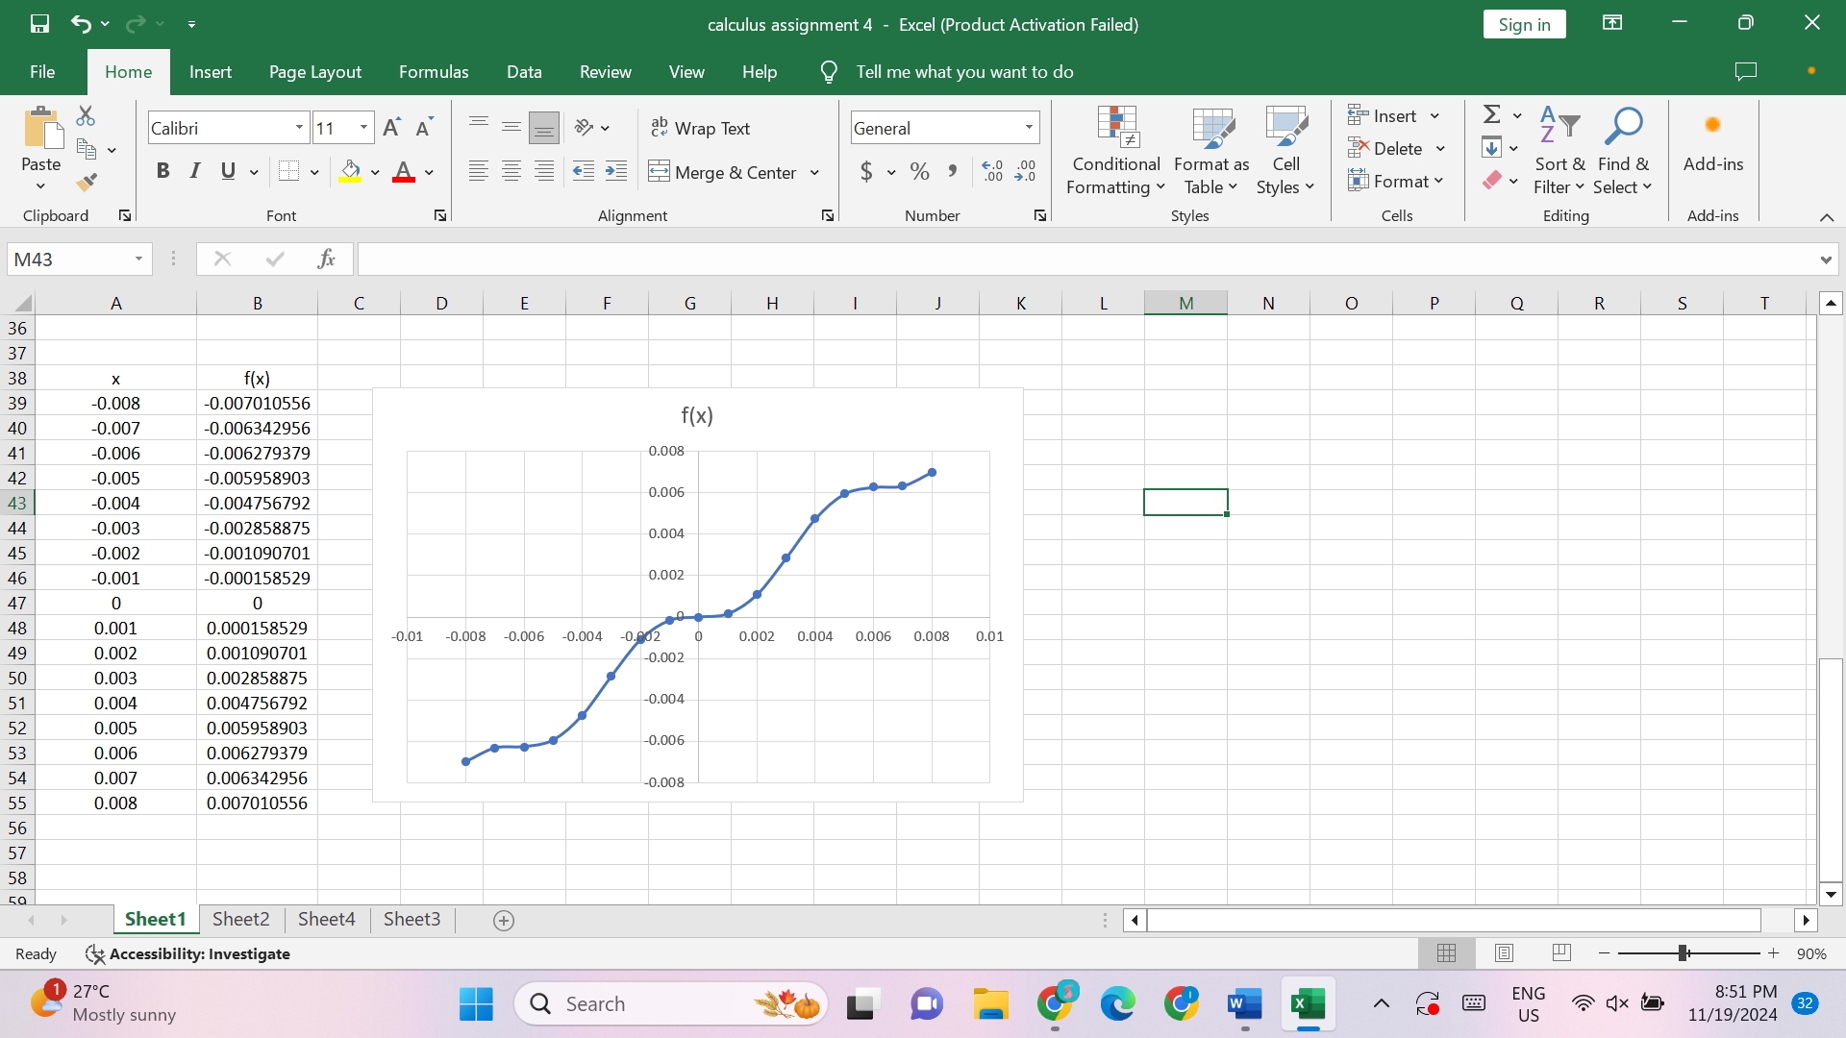

The slope of the graph at the origin is zero: f ′ (0) = 0.

Q2.





Zoom in towards the point (−1, 0). Notice that the graph is a straight line.

At the point (−1, 0), the graph is smooth and linear and the function is differentiable.

Q3.

f’-(a)= $\lim_{h→0}_$ $\frac{f\left(a+h\right)-f{(a)}}{h}$

f’+(a)= $\lim_{h→0+}$ $\frac{f\left(a+h\right)-f{(a)}}{h}$

(a)

f’-(4) = $\lim_{h→0}_$ $\frac{f\left(4+h\right)-f{(4)}}{h}$

= $\lim_{h→0}_$ $\frac{f\left(4+h\right)-f{(4)}}{h}$

= $\lim_{h→0}_$ $\frac{5-4-h-5+4}{h}$

= $\lim_{h→0}_$ $\frac{-h}{h}$

= -1

f’+(4) = $\lim_{h→0+}$ $\frac{f\left(4+h\right)-f{(4)}}{h}$

= $\lim_{h→0+}$ $\frac{\frac{1}{5-4-h}{-\frac{1}{5-4}}}{h}$

= $\lim_{h→0+}$ $\frac{\frac{1}{1-h}{-1}}{h}$

= $\lim_{h→0+}$ $\frac{\frac{1}{1-h}{-\frac{1-h}{1-h}}}{h}$

= $\lim_{h→0+}$ $\frac{\frac{h}{1-h}}{h}$

= $\lim_{h→0+}$ $\frac{1}{1-h}$

= $\frac{1}{1-0}$

= 1

(b)

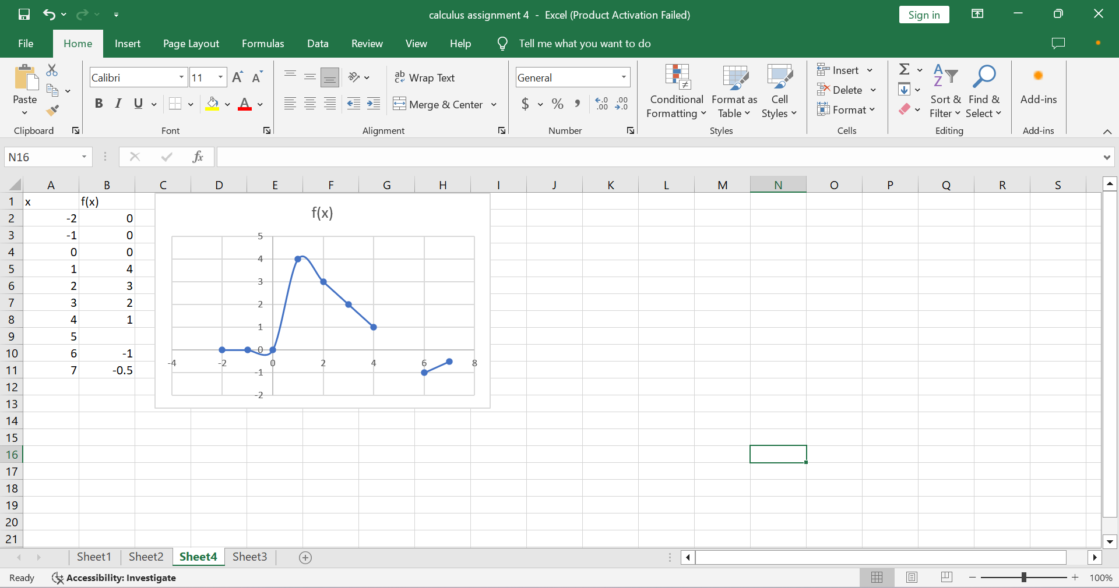

(c) f is discontinuous at x=5

(d) f is not differentiable at x=5.

Q4.

g(x)= x f(x)

g’(x) = $\lim_{h→0}$ $\frac{g\left(x+h\right)-g\left(x\right)}{h}$

g(x+h) = (x+h) f (x+h)

g(x) = x f(x)

g’(x) = $\lim_{h→0}$ $\frac{\left(x+h\right)f\left(x+h\right)-xf\left(x\right)}{h}$

(x+h) f (x+h) = x f (x+h) + h f (x+h)

So,

g’(x) = $\lim_{h→0}$ $\frac{xf\left(x+h\right)+hf\left(x+h\right)-xf\left(x\right)}{h}$

g’(x) = $\lim_{h→0} [ x$ $\frac{f\left(x+h\right)-f\left(x\right) }{h}+f(x+h)]$

$\lim_{h→0}$ $\frac{f\left(x+h\right)-f\left(x\right)}{h}$ = f’(x)

$\lim_{h→0}$ f(x+h) = f(x)

g’(x) = xf’(x) + f(x)

Q5.

By Boyle’s Law,

P ∝ $\frac{1}{V}$

P =k $\frac{1}{V}$

50 kPa = $\frac{k}{0.106 }$

k=5.3 kPa m3

P=

V=

= ()=5.3kPa (P-1)= -(5.3kPa)P-2

P=50 kPa

= () = - (5.3 kPa) )(50)-2 m3

P has units of kPa, dV /dP has units of m3/kPa.

Q6.



As a quadratic function,

L(P) = aP2+bP+c

L(P) = - 273.55 +19.749P – 0.27543P2

.= (-273.55+19.749P – 0.27543P2)

= (-273.55)+(19.749P) – (0.27543P2)

= (-273.55)+19.749(P) –0.27543 (P2)

= 19.749-0.55086P

When P=30,

. $\frac{dL}{dP}$ =19.749_0.55086(30)= 3.2229

When P=40,

. $\frac{dL}{dP}$ =19.749_0.55086(40)= -2.2857

The units of $\frac{dL}{dP}$ are kilomiles over pounds per square inch.

[$\frac{dL}{dP}$] = $\frac{kilomile}{\frac{lb}{{in}^{2}}}$

If $\frac{dL}{dP}$ is positive, then the tire life increases with increasing pressure, and if dL/dP is negative, then the tire life decreases with increasing pressure.